Assignment #1 – Business 100
Name: Heather cain shephard
Step 1: Product Life Cycle
Background Information Needed to Answer Question #1:

Review the Sales Report below for Alikay Naturals Moisturizing Black Soap Shampoo.

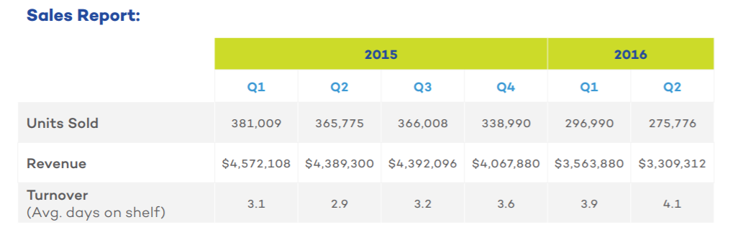
As you recall from our learning, here are the four phases of the product life cycle:
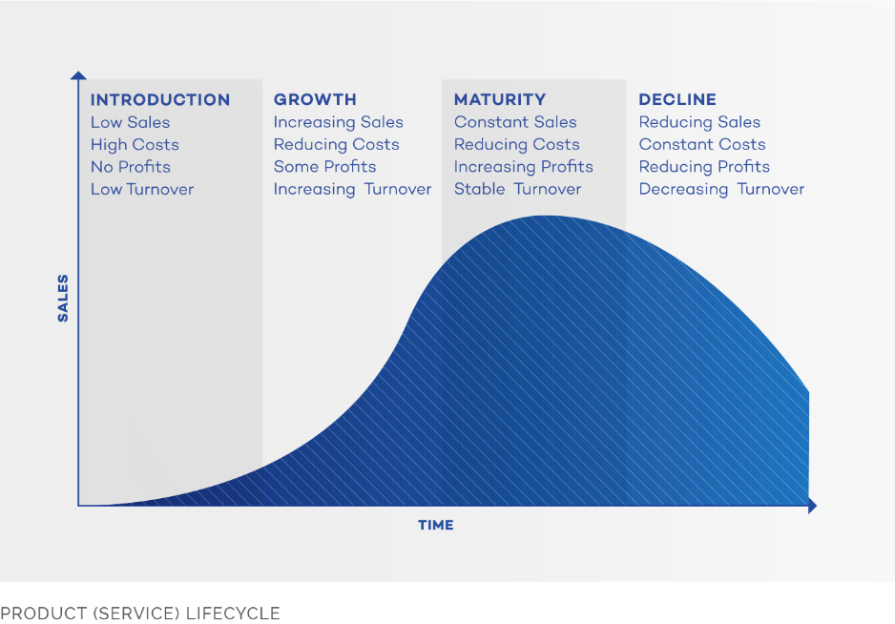

Question 1:
What phase of the product life cycle is the Moisturizing Black Soap Shampoo currently in?
- Introduction
- Maturity
- Growth
- Decline
Describe why you selected that phase using sales report data and what you know about the product life cycle in the box below:
The Moisturizing Black Soap Shampoo is definitely in the decline stage of a product life cycle. The sales report information provided supports this trend .The product is in the stage of decline because it shows the increase in the rates of turnovers Q1 and Q2 of the year2016, which is from 3.9 to 4.1 days on company’s the shelves. The longer the time the product spends on the shelf, the smaller the number of quantities need to be bought at wholesale cost to redistribute and resell in various retail outlets. Between, Q1 and Q2 the units of the product sold declined by 21,214 units and the profit has dropped by $254,568

Step 2: Product Changes
Background Information Needed to Answer Question #2:

Review the User Survey Summary data below and form some opinions about the shampoo’s consistency, smell, effectiveness, and price. Based on this information you will be able to answer question #2.
I will make three important recommendations for Alikay Naturals to improve the Moisturizing of the black Soap Shampoo.
Firstly, fifty-six percent of the potential consumers surveyed below strongly disagree or disagree that the organization’s product has a pleasant smell. This an economic issue that should be fixed appropriately. The unpleasant smell of the brand establishes a negative impression making the customers to stop consuming the product and shift to its close substitute in the market .Therefore the company should focus on how to deal with this negative impression and attitude created among the potential customers because it adversely affect the demand of the product. The production manager should altering initial production formula to make the scent of the soap more appealing to satisfy the current and potential customers.
Secondly, sixty-three of non-consumers surveyed in the table below strongly disagree on the density of the product. Considering the comments outline in the bottom of the survey. It shows clearly that to the product does not meet the customers’ requirements in its entirety because it is too watery, hence making the customers to use a lot of soap as unexpected hence leading to wastage. The client does not want incur expenses on products that does not satisfy his or her needs as described by the producer or manufacturer. I suggest that company to relook the thickening formula and producing product of the right size and density to meet the needs of the consumer. Thus, the company focus the product more gelatinous and thick.
3. There has been a substantial quality decline noticed by consumers. I suggest revisiting the original formula, and the sales at the time, then compare the statistical data to that which was collected during the formula change.
Question 2:
What recommendation(s) do you have for Alikay Naturals to improve or replace Moisturizing Black Soap Shampoo? Pleas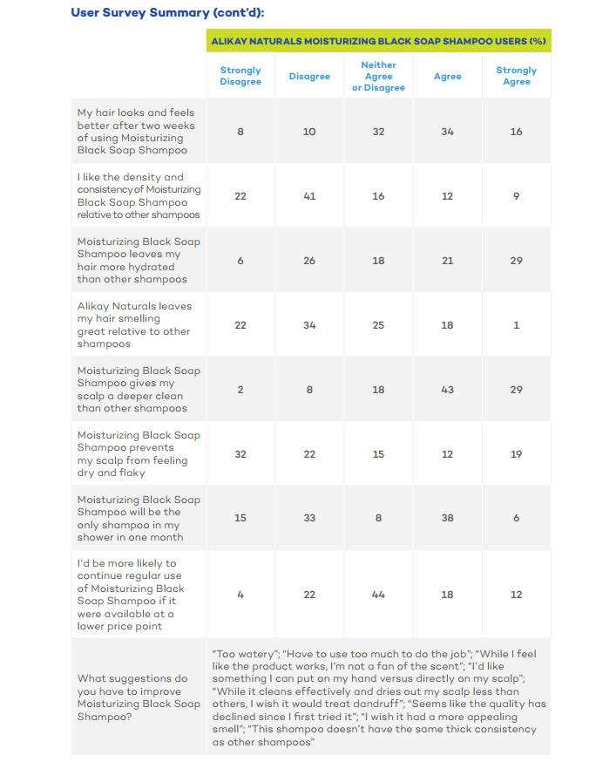e support your recommendation(s) utilizing the data below:

Step 3: New Product Development
Background Information Needed to Answer Question #3:
Review the three new product options and based on the survey results below determine which of the three new products you would recommend.

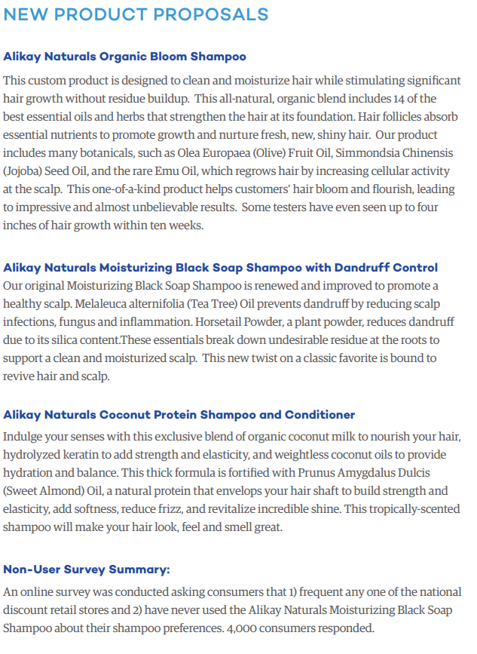
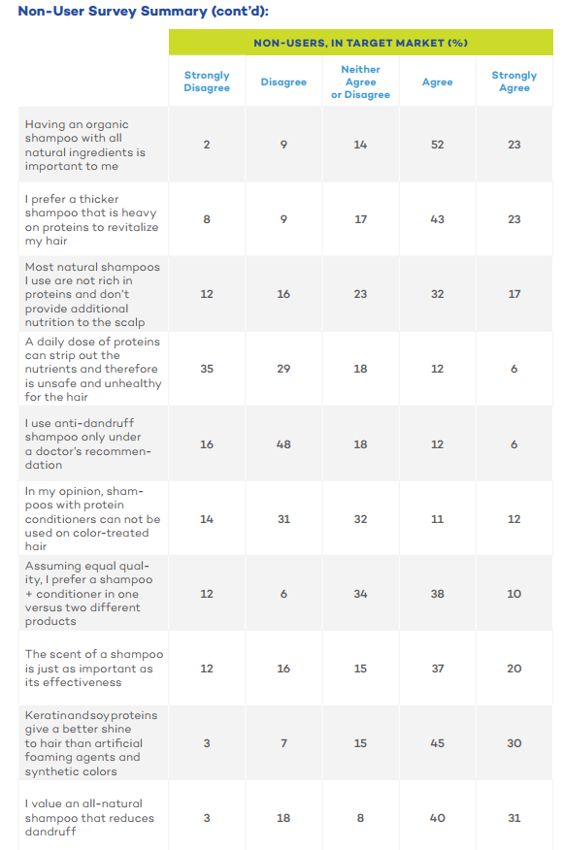
Question 3:
If you had to recommend one product, which product would you recommend they create? Underline or highlight your answer:
- Organic Bloom Shampoo
- Moisturizing Black Soap Shampoo with Dandruff Control
- Coconut Protein Shampoo and Conditioner

Explain your decision. Provide examples of the customer feedback that informed your choice.
I would recommend the Coconut Protein Shampoo and Conditioner. Looking at the survey provided above, it shows 66% of the potential clients have a positive taste and preference for the thick shampoo. By comparing the information provided in the survey and the information outlined in the current customers report which clearly indicates that the shampoo is having unappealing texture, as well as is watery. I therefore, believe that Coconut Protein Shampoo and conditioner will definitely satisfy the needs of the potential and current clients. Additionally more than 50 percent of the client indicated that the shampoo’s scent is as significant effectiveness and efficiency of products, the coconut scent would enhance the scent taste of both the current and future customers.

question 4: Innovation
- Determine which type of innovation your new product represents from among the four main types discussed this week. Underline or highlight your selection:
- Sustainable (eco-friendly)
- Frugal
- Sustaining
- Disruptive

Briefly explain why you chose that type of innovation.
The new product would represent a sustainable innovation. First I thought it would the sustaining innovation, but because the organization is looking forward to create completely new products, then sustaining innovation would not be appropriate. Because Alikay brand usually utilizes the organic and natural resources as the raw materials in the production process, which enhances sustainability in the market as well in the ecosystem.

Helpful image from Week 2 Learn’s section for your review:

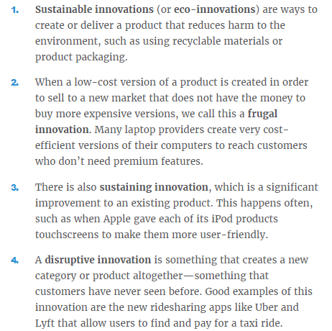

Question 5: Production Methods
Based on the product you chose in Answer 3 determine which production method is most appropriate for the production of this product. Underline or highlight your answer:
- Job Production
- Batch Production
- Flow Production
- Mass production

Explain your decision below:
Flow production is the appropriate production method in this case. Because Alikay produces small quantities of products, mass production method is not the appropriate method of production. Considering the quantities of the products being produced which will be two, Job production is not the feasible production method in this scenario. The main reason that job and batch production are both inappropriate methods of production is because none of the products Alikay creates are customizable in the market.

Helpful images from Week 3 Learn’s section for your review:
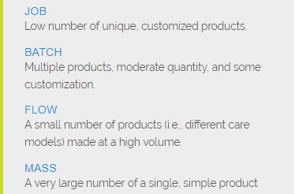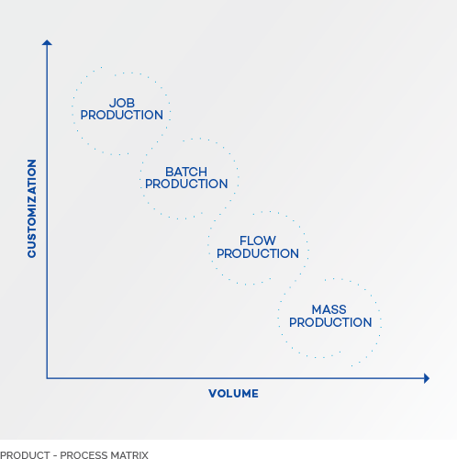

Next step: submit your work
- Save this document to your desktop
  - Navigation: select file at the top, save as – select desktop, and select save
- Log into your class and select Assignment #1 on the left, scroll down and select “submit your work”, click browser my computer, find your file on the desktop, click open, then click submit.
- If you have any issues please email me or call

I will provide you assignment feedback and you can then make any changes you would like and resubmit for grading.
Congrats on completing assignment #1!

